Interact Learning

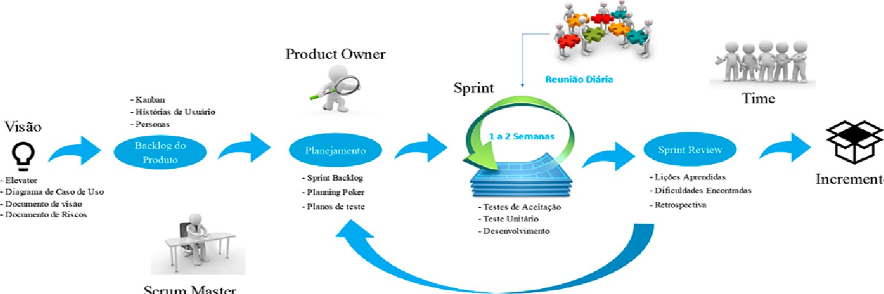

to

Scrum

Master